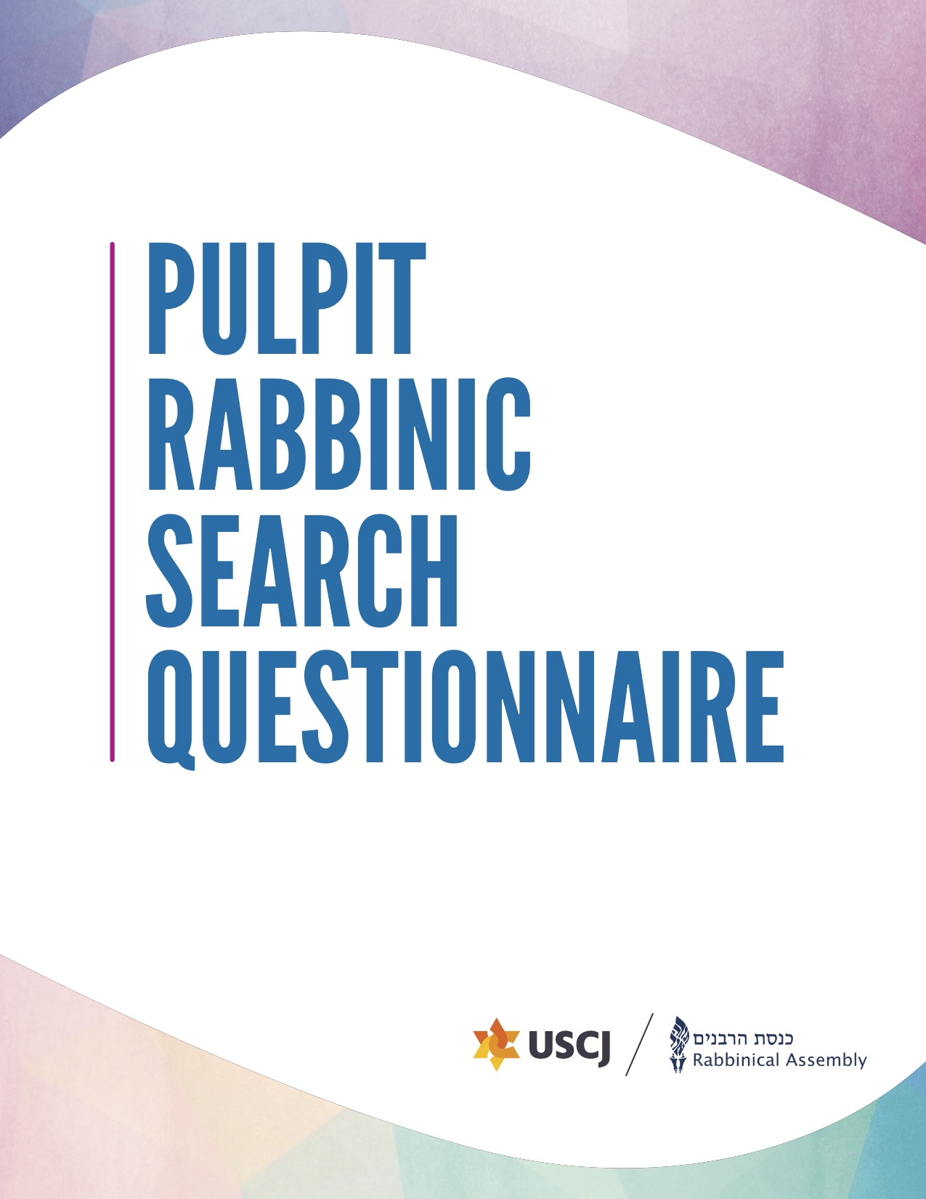

Rabbinic Search Questionnaire
The Partnership for Congregational Rabbinic Search created this questionnaire to help meet the needs of today’s synagogues and rabbis. Completing it will help clarify your synagogue’s unique strengths and challenges. Your thoughtful answers here will help rabbis understand who you are as a congregation.
The form is now completely online. You can use this worksheet as a draft, but it will all need to be transferred online. If you prefer to complete it online from the start, you can work on it slowly and save it as draft until it is complete, then click submit. PLEASE NOTE: there are character limits. If you wish to use this worksheet, please double check your characters so you will not be cut off when transferring it to the online form.
Here is a video tutorial to walk you through the process.
The first step is to register for an account. We have been using this system since August 2021, so if you created an account prior to that date, you will need a new one. Also, if you have used an email address for an RA account for any purpose before, they will need a new email address to register.
There are 12 sections to the questionnaire. Most congregations work together to create a document based on reflection, intention, honesty, and public discussion. Then, the document is often divided between the committee to complete (for example, assigning the financial pieces to the Treasurer).
First, you will provide general contact information. Then, there is a section about your new rabbi, which will allow candidates to determine if they are the correct potential fit. Next, there are sections about the Jewish and general community in your city. The next few segments ask about your congregation and give you the opportunity to tell your story. Here, you can write about your values, mission, members, finances, space, and staff history. Then, there is a section to write about your religious and spiritual life and programming. Finally, we will ask about proposed compensation. You are committing to these numbers as a congregation.
Red asterisks (*) denote required questions.
For any questions about the rabbinic search process, please reach out to your Mindy Gordon, Director of Clergy Search and Services at USCJ, or to the RA Career Center.

Table of Contents
Rabbinic Search Questionnaire 2
Section 1: General Information 4
Key Contacts for Search Process 4
Section 2: Your New Rabbi 5
Section 3: Jewish Community 7
Section 4: General Community 7
Section 5: Your Story, Values, and Mission 8
Section 6: Your Members 9
Section 7: Synagogue Finances 9
Section 7: Your Space 10
Section 8: Your Staff History 10
Section 9: Religious and Spiritual Life 11
Section 10: Synagogue Life, Learning, Outreach, and Programming 12
Section 11: Housing 13
Section 12: Monetary Compensation and Benefits 14

Section 1: General Information
In this section, we’ll ask for basic contact information for your synagogue and leaders.
Synagogue Name: *
Country: *
Street Address: *
City: *
State: *
Zip Code: *
Telephone: *
Website: *
Facebook Page:
Twitter Handle:
Other Social Media:

Key Contacts for Search Process
Synagogue President Name: *
Synagogue President Email: *
Synagogue President Phone Number: *
Search Committee Chair: *
Search Committee Chair Email: *
Search Committee Chair Phone Number: *
Search Committee Co-Chair:
Search Committee Co-Chair Phone Number:
Search Committee Co-Chair Email:

Section 2: Your New Rabbi
In this section, we will ask for information that will help rabbis determine their potential fit as your rabbi. Here is a short 2-minute video explaining this priorities section. Rabbis will also fill out a “Rabbinic Skills” worksheet to identify their top skills from the same list that is below. You will receive this self-assessment together with each candidate’s resume.
Are you searching for a: *
- Senior/Solo Rabbi
- Assistant/Associate Rabbi
- Interim/Transitional Rabbi
- Part Time Rabbi
Please identify up to five (5) skills/qualifications necessary for the position for which you are hiring. (Select up to 5)
Pastoral
- Pastoral Counseling and Care
- Lifecycle/Creative Ritual
- Community Organizing
Education
- Early Childhood or Preschool
- K-12 Education/Programming
- Adult Education/Programming
- Scholarship – text knowledge/Halakhah/Hebrew
Pulpit
- Musical Abilities
- Prayer Leader
- Public Speaking - sermonizing, framing, depth
- Torah Reading

(options continue on next page)
Management
- Executive Functioning
- Board Development and Management
- Supervision (staff and/or volunteers)
- Fiscal Responsibility - budget and administration
- Advancement/Fundraising
- Negotiating Conflict
Leadership
- Social Activism
- Larger Community Involvement (inside/outside)
- Visionary Leadership and Strategic Planning
- Engagement with Israel
Other ___________
Please comment on the ways in which 2-3 of the skills you identified are essential skills for your next rabbi. (Limit 2000 characters) *
Why are you currently searching for a new rabbi? (Limit 1000 characters) *
What do you see as the top initiatives/responsibilities for your new rabbi? (Limit 200 characters) *
What role do you want the rabbi to play in leading the congregation, at board meetings and in synagogue leadership? (Limit 2000 characters)
What do you want your next rabbi to change? What do you want them to preserve? (Limit 2000 characters) *
If you are looking for an interim rabbi, what special needs do you have at this time? (Limit 1500 characters)
Feel free to comment on the opportunities for mentoring, growth, and leadership opportunities. (Limit 1500 characters, optional)
What is your projected start date for your new rabbi? *

Section 3: Jewish Community
In this section, we’ll ask for information about the Jewish and general community in your city.
Please describe your Jewish community (not just your synagogue), including population and key institutions. (Limit 2500 characters) *
Please add links to relevant websites so that rabbis can learn more.
Are there Jewish day schools in your community? (Yes/No) *
Please describe them and note any relationship that your synagogue has with them. (Limit 1500 characters)
How many students from your synagogue attend those schools? * (numbers only)
Are there other synagogues nearby? (Yes/No) *
Please describe them and note any relationship your synagogue has with them. (Limit 1500 characters)
Is there a mikveh in the community? (Yes/No) *
Is there an eruv in the community that includes your synagogue? (Yes/No) *

Section 4: General Community
Please describe your general community, including population, lifestyle, weather, economy. (Limit 2500 characters) *
Please describe any relationships with local news, government, and law enforcement. (Limit 2000 characters) *
It’s helpful to add relevant websites so that rabbis can learn more about what it’s like to live in your city.

Section 5: Your Story, Values, and Mission
In this section, we’ll ask for information about your synagogue, including your story as a congregation, information about the diversity of your members, your physical space and financial resources, your staff members, and your religious and spiritual life.
Who are you as a congregation? Please tell your story here. (Limit 2000 characters) *
What are the core values and principles of your congregation? Please include links to your mission/values/vision statements. (Limit 2500 characters) *
How is your synagogue different from other congregations in your city or region? (Limit 1500 characters) *
Please share a recent example of your synagogue demonstrating one of its strengths. (Limit 1000 characters) *
Please share a recent example of your synagogue dealing with one of its challenges. (Limit 1500 characters) *
How has your congregation changed over the last few years? (Limit 1000 characters) *
How do you think your congregation will change over the next few years? (Limit 1000 characters) *
How would you like it to change? (Limit 1000 characters) *
Are there pieces of your congregation you do not want to change? Please explain. (Limit 1000 characters) *
How does your congregation manage change? (Limit 1000 characters) *
How does your congregation process conflict? (Limit 1000 characters) *
Who is involved in the change process? (Limit 1000 characters) *
What is the process by which decisions are usually made? Who are the key players? (Limit 1000 characters) *

Section 6: Your Members
Please describe the demographic groups in your congregation (e.g. multigenerational families, newcomers, singles, mature adults, interfaith families, or other groups). (Limit 1000 characters) *
How are relationships built and maintained in your congregation? (Limit 2000 characters) *
How are new members welcomed and integrated into your congregation? (Limit 1000 characters) *
How many member units are currently in your congregation? (numbers only)
Please describe your membership categories and the numbers and trends in each. (Limit 2000 characters) *

Section 7: Synagogue Finances
In the most recently completely fiscal year, what was the size of the synagogue budget? Please convert to United States Dollars * (Format: 9.99)
In addition to dues, what revenue streams are part of your budget? (Limit 1000 characters) *
Describe the structure of dues at your synagogue. *
Please provide the percentage of your budget devoted to operations/infrastructure, staff, programming, and any other categories. *
Does the congregation currently have a deficit? (Yes/No) *
If so, how do you manage the deficit? (Limit 1000 characters)
Are you currently fundraising for, or prospectively considering a capital campaign? (Yes/No) *
If so, please describe its progress and timeline. (Limit 1000 characters)
Does the rabbi play a role in fundraising? (Yes/No) *
If so, please describe the role.

Section 7: Your Space
Please describe your synagogue space, including where you meet for services and other activities (feel free to include photos). (Limit 1000 characters) *
Photos Of Synagogue Space (Optional file upload. Maximum 3 files. 80 MB limit. Allowed types: png gif jpg jpeg)
Please describe the rabbi’s office space. (Limit 1000 characters) *
Describe any plans (or dreams) to change your space. (Limit 1000 characters) *
Describe your synagogue's on-site security and other security protocols. (Limit 1000 characters) *

Section 8: Your Staff History

Current Rabbi:
- Name (If you do not have a current rabbi, please write “n/a”):*
- Years Served: *
- Email Address: *
- Phone Number: *
Preceding Rabbi*
- Name: *
- Years Served: *
- Email Address: *
- Phone Number: *
Does your congregation have a cantor? (Yes/No) *
- Cantor’s Name:
- Years Served:
- Email Address:
- Phone Number:

Does your congregation have an Executive Director? (Yes/No) *
- Executive Director’s Name:
- Years Served:
- Email Address:
- Phone Number:
Does your congregation have a staff person dedicated to education? (Yes/No) *
- Educator’s Name:
- Years Served
- Email Address
- Phone Number
Other Staff (please specify, for example an assistant/associate rabbi):

Section 9: Religious and Spiritual Life
Please describe prayer and spiritual life at your synagogue. (Limit 2000 characters) *
What are services like for regulars? For newcomers and visitors? (Limit 1000 characters)*
Which siddurim do you use on weekdays? (Limit 1000 characters) *
Which siddurim do you use on Shabbat? (Limit 1000 characters) *
Which mahzorim do you use on High Holidays? (Limit 1000 characters) *
Do you have a sermon or Torah discussion? (Select 1: Sermon, Torah Discussion, Other) *
Do you read Torah on the annual or triennial cycle? (Annual, Triennial, Other) *
Who normally reads Torah? (Select as many as applicable: Rabbi, Cantor, Congregants, Torah Reader) *
How do you balance congregational singing with familiar tunes and traditional nusah? (Limit 1000 characters) *
What is the balance of Hebrew and English used? (Limit 1000 characters) *
How many people usually attend services (weekday morning, evening, Shabbat evening, Shabbat morning)? *
Please describe High Holy Day services in your congregation, including any parallel, family, or other special services? (Limit 1000 characters) *
What religious service is the synagogue most proud of and why? (Limit 1000 characters)*
Are any of your services accessible by Zoom or Livestreaming? (Yes/No) *
Please describe your services that are accessible online.
What are your practices regarding kashrut? (Limit 1000 characters) *
What are your practices regarding egalitarianism? (Limit 1000 characters) *
Describe what diversity and inclusion looks like in your congregation. (Limit 2000 characters) *
We attended or are planning to attend the Communities of Belonging Training on: (Select one: October 14, 2026; December 3, 2026; February 3, 2027; We did not/are not planning to attend one of these trainings) *

Section 10: Synagogue Life, Learning, Outreach, and Programming
Describe one or more synagogue events of which your congregation is most proud. (Limit 2000 characters) *
Describe your current adult education program, participation, and its goals. (Limit 1000 characters) *
Describe your synagogue’s involvement in the larger Jewish and non-Jewish communities. (Limit 2000 characters) *
What does your congregation do to reach out to the unaffiliated?(Limit 1000 characters)*
What committees and programs should the rabbi know about? (Limit 1500 characters) *
Describe your educational program and goals for children. (Limit 1500 characters) *
Does your congregation have a preschool or early childhood program? (Yes/No) *
If so, does it meet onsite? Is it shared or independent? (Onsite and Independent, Onsite and Shared, Offsite)
Do you have a Hebrew School? (Yes/No) *
Does your Hebrew School meet in person or virtually? (In Person/Virtually)
What role does the rabbi have in the school? (Limit 1000 characters)
How many students are in each grade?
How many b’nai mitzvah does your congregation celebrate on average per year? *
What is your congregation especially proud of in its b’nai mitzvah program? (Limit 1000 characters) *
Does your congregation have a post b’nai mitzvah program? (Yes/No) *
If so, please describe and indicate how many teens are involved.(Limit 1000 characters)*
Please describe your youth program and indicate what you are most proud of in it. (Limit 1000 characters) *
How many children in your congregation go to Camp Ramah/Noam Camp? *
How many children in your congregation are involved with USY/Noam? *
What other youth movements and camps are popular in your community?
How does your congregation connect to the college age population? (Limit 1000 characters) *

Section 11: Housing
Is housing provided by the congregation? (Yes/No) *
If yes, what is the distance from the synagogue?
If yes, please describe the housing and include the address and photos or links. (Limit 1000 characters)
Photos Of Housing (Optional file upload, maximum 5 files. 80 MB limit. Allowed types: png gif jpg jpeg)
What is the estimated value of the housing? (Numbers only)
If the synagogue does not provide housing, please describe nearby housing options, cost to rent or buy, and the distance from the synagogue. (Limit 1000 characters)
What websites can rabbis use to check on housing in your community? *
Have previous rabbis felt the need to drive on Shabbat? *
Are you willing to offer the rabbi a loan to purchase a residence? *

Section 12: Monetary Compensation and Benefits
In this section, you must provide specific amounts for compensation. This is REQUIRED, and applications without actual numbers will not be processed. You are committing to these numbers as a congregation. If there are no additional benefits, please indicate that it is an all-inclusive package.
Proposed Minimum Base Salary (not including benefits) (Please convert to United States Dollars. Format: 9.99): *
Proposed Maximum Base Salary - Optional (not including benefits) (Please convert to United States Dollars, Please do not create a range larger than $20,000.):
Pension contribution (monetary amount or percentage of base salary): *
Please select all of the following benefits that you provide in addition to the base salary stated above.
- Major Medical Insurance
- Hospitalization
- Disability Insurance
- FICA Coverage or Reimbursement (for US congregations)
- Supplementary Health Insurance (for Canadian congregations)
- Convention Allowance/Continuing Education
- Rabbinical Assembly Annual Dues
- Synagogue or Day School Tuition Reimbursement for Rabbi’s Children
- Ramah or Other Camp Scholarship for Rabbi’s Children
If you selected insurances above, is this solely for the rabbi or does it include family? *
Please describe any additional benefits not listed above. (Limit 2000 characters) *
Vacation (number of weeks annually) *
Please describe your parental and family leave policy. (Limit 1000 characters) *
Total Compensation Minimum (Value of Housing + Base Compensation + Value of Benefits) (Please convert to United States Dollars. Format: 9.99): *
Total Maximum Compensation - Optional (Value of Housing + Base Compensation + Value of Benefits) (Please convert to United States Dollars.)
Optional Additional Document Upload (e.g. letter from a senior rabbi about senior-assistant working relationship) (One file only, 80 MB limit, File types allowed: pdf doc docx).

