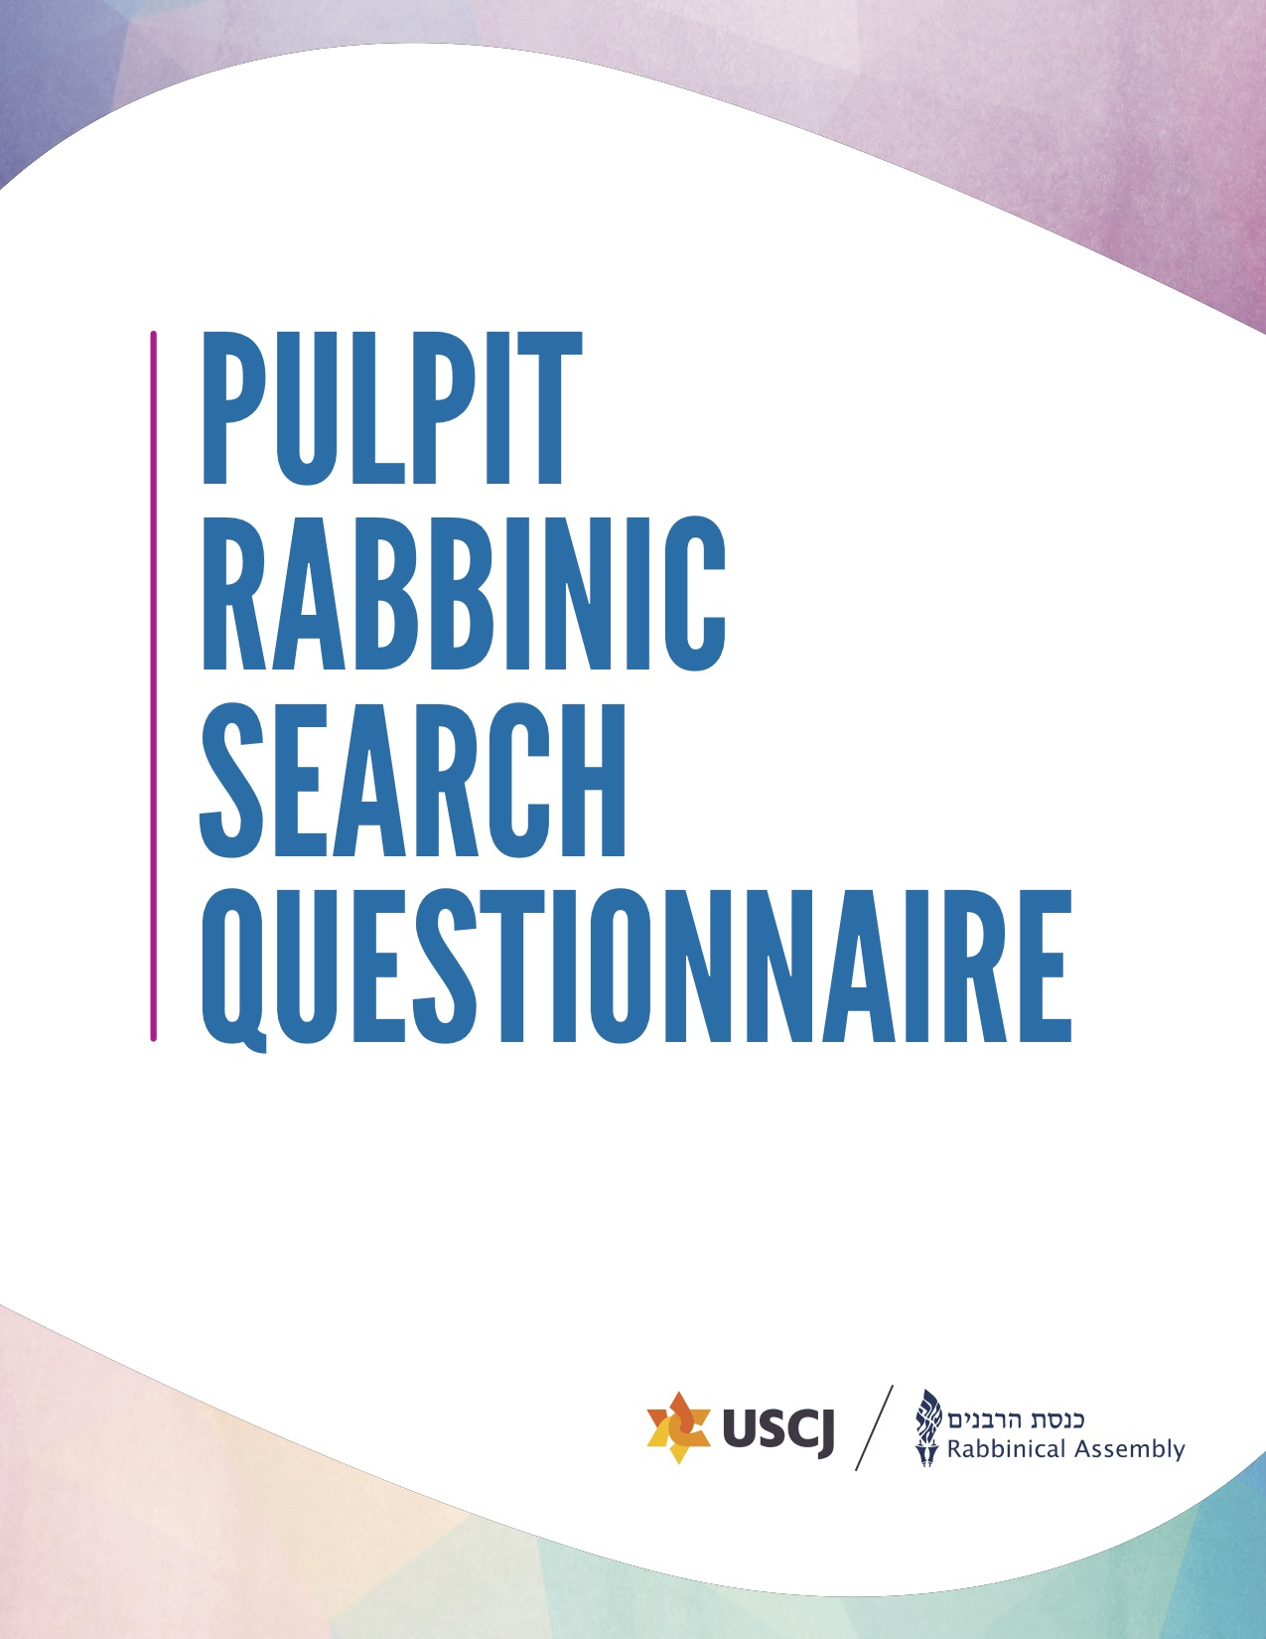

Rabbinic Search Questionnaire
The Joint Placement Commission of the Rabbinical Assembly and the United Synagogue of Conservative Judaism created this questionnaire to help meet the needs of today’s synagogues and rabbis. Completing it will help clarify your synagogue’s unique strengths and challenges. Your thoughtful answers here will help rabbis understand who you are as a congregation.
The form is now completely online. You can use this worksheet as a draft, but it will all need to be transferred online. If you prefer to complete it online from the start, you can work on it slowly and save it as draft until it is complete, then click submit. PLEASE NOTE: there are now character limits. If you wish to use this worksheet, please double check your characters so you will not be cut off when transferring it to the online form.
Here is a video tutorial to walk you through the process.
The first step is to register for an account. This is a new system as of August 2021, so you will need a new account, even if you had one before. Please note: if you have used an email address for an RA account for any purpose before, they will need a new email address.
There are five sections to the questionnaire. Most congregations work together to create a document based on reflection, intention, honesty, and public discussion. Then, the document is often divided between the committee to complete.
First, in Section 1 we will ask general contact information. Then, in Section 2 we will ask about your new rabbi, which will allow candidates to determine if they are the correct potential fit. In Section 3, we ask about the Jewish and general community in your city. Section 4 is the longest section, which asks about your congregation and gives you the opportunity to tell your story. Here, we will ask about your values, mission, members, finances, space, and staff history. We will also ask about your religious and spiritual life and programming. Finally, we will ask about proposed compensation. You are committing to these numbers as a congregation.
For any questions about the rabbinic search process, please reach out to your USCJ synagogue consultant or to the RA Career Center careercenter@rabbinicalassembly.org or 212-280-6000.

Table of Contents
Rabbinic Search Questionnaire 2
Section 1: General Information 4
Key Contacts for Search Process 4
Section 2: Your New Rabbi 5
Section 3: Your Jewish and General Community 6
A. Jewish Community 6
B. General Community 6
Section 4: Your Congregation 6
A. Your Story, Your Values, Your Mission 7
B. Your Members 7
C. Synagogue Finances 8
D. Your Space 8
E. Your Staff History 9
F. Religious and Spiritual Life 9
G. Synagogue Life, Learning, Outreach, and Programming 10
Section 5: Proposed Compensation 11
A. Housing 12
B. Monetary Compensation 12
C. Benefits 12
D. Total Compensation (Value of Housing + Base Compensation + value of Benefits) REQUIRED: 13

Section 1: General Information
In this section, we’ll ask for basic contact information for your synagogue and leaders.
Synagogue Name:
Address:
City:
State/Province:
Postal Code:
Country:
Telephone:
Website:
Facebook Page:
Twitter Handle:
Other Social Media:

Key Contacts for Search Process

Title | Name | Email | Phone
Synagogue President
Search Committee Chair
Search Committee Co-Chair

Section 2: Your New Rabbi
In this section, we will ask for information that will help rabbis determine their potential fit as your rabbi.
Are you searching for a Senior Rabbi, Associate Rabbi, or an Interim Rabbi?
Why are you currently searching for a new rabbi? (Limit 1000 characters)
What do you see as the top priorities for your new rabbi? (Limit 2500 characters)
What role do you want the rabbi to play in leading the congregation? (Limit 1000 characters)
What is the rabbi’s role at board meetings and in synagogue leadership? (Limit 1000 characters)
What do you want your next rabbi to change? (Limit 2000 characters)
What do you want your next rabbi to preserve? (Limit 2000 characters)
Based on who you are as a congregation and your goals for the future, what are some qualities, skills, and areas of expertise that you think your new rabbi would have or develop? (Limit 2000 characters)
Please describe features or customs of your congregation that rabbis might find unique or particularly attractive. (Limit 2000 characters)
If you are looking for an interim rabbi, what special needs do you have at this time?
If you are looking for a second rabbi, please indicate what special responsibilities they may have. (Limit 1500 characters)
Please include a statement from your senior rabbi about mentoring, growth, and leadership opportunities. (Limit 1500 characters)

Section 3: Your Jewish and General Community
In this section, we’ll ask for information about the Jewish and general community in your city.

A. Jewish Community
Please describe your Jewish community (not just your synagogue), including population and key institutions. (Limit 2500 characters)
Please add links to relevant websites so that rabbis can learn more.
Are there Jewish day schools in your community? (Yes/No)
Please describe them and note any relationship that your synagogue has with them. (Limit 1500 characters)
How many students from your synagogue attend those schools?
Are there other synagogues nearby? (Yes/No)
Please describe them and note any relationship your synagogue has with them. (Limit 1500 characters)
Is there a mikveh in the community? (Yes/No)
Is there an eruv in the community that includes your synagogue? (Yes/No)

B. General Community
Please describe your general community, including population, lifestyle, weather, economy. (Limit 2500 characters)

Please describe any relationships with local news, government, and law enforcement. (Limit 2000 characters)
It’s helpful to add relevant websites so that rabbis can learn more about what it’s like to live in your city.

Section 4: Your Congregation
In this section, we’ll ask for information about your synagogue, including your story as a congregation, information about the diversity of your members, your physical space and financial resources, your staff members, and your religious and spiritual life.

A. Your Story, Your Values, Your Mission
Who are you as a congregation? Please tell your story here. (Limit 2000 characters)
What are the core values and principles of your congregation? If you have mission/values/vision statements, please include or link to them here. (Limit 2500 characters)
How is your synagogue different from other congregations in your city or region? (Limit 1500 characters)
Please share a recent example of your synagogue demonstrating one of its strengths. (Limit 1000 characters)
Please share a recent example of your synagogue dealing with one of its challenges. (Limit 1500 characters)
How has your congregation changed over the last few years? (Limit 1000 characters)
How do you think your congregation will change over the next few years? (Limit 1000 characters)
How would you like it to change? (Limit 1000 characters)
Are there pieces of your congregation you do not want to change? Please explain. (Limit 1000 characters)
How does your congregation manage change? (Limit 1000 characters)
How does your congregation process conflict? (Limit 1000 characters)
Who is involved in the change process? (Limit 1000 characters)
What is the process by which decisions are usually made? Who are the key players? (Limit 1000 characters)

B. Your Members
Please describe the demographic groups in your congregation (e.g. multigenerational families, newcomers, singles, mature adults, interfaith families, or other groups). (Limit 1000 characters)
How are relationships built and maintained in your congregation? (Limit 2000 characters)
How are new members welcomed and integrated into your congregation? (Limit 1000 characters)
How many member units are currently in your congregation?
Please describe your membership categories and the numbers and trends in each. (Limit 2000 characters)

C. Synagogue Finances
In the most recently completely fiscal year, what was the size of the synagogue budget?
In addition to dues, what revenue streams are part of your budget?
Describe the structure of dues at your synagogue.
Please provide the percentage of your budget devoted to operations/infrastructure, staff, programming, and any other categories.
Does the congregation currently have a deficit? (Yes/No)
If so, how do you manage the deficit? (Limit 1000 characters)
Are you currently fundraising for, or prospectively considering a capital campaign? (Yes/No)
If so, please describe its progress and timeline. (Limit 1000 characters)
Does the rabbi play a role in fundraising? (Yes/No)

D. Your Space
Please describe your synagogue space, including where you meet for services and other activities (feel free to include photos). (Limit 1000 characters)
Please describe the rabbi’s office space. (Limit 1000 characters)
Describe any plans (or dreams) to change your space. (Limit 1000 characters)

E. Your Staff History
 | Name | Years Served | Email | Phone
Current Rabbi
Preceding Rabbi
Preceding Rabbi
Cantor
Executive Director
Educator
Others (please specify)

F. Religious and Spiritual Life
Please describe prayer and spiritual life at your synagogue. (Limit 2000 characters)
What are services like for regulars? For newcomers and visitors? (Limit 1000 characters)
What siddurim/mahzorim do you use?
- Weekdays:
- Shabbat:
- High Holidays:
Do you have a sermon or Torah discussion?
Do you read Torah on the annual or triennial cycle?
Who normally reads Torah (congregants, paid Torah reader, rabbi, cantor)?
How do you balance congregational singing with familiar tunes and traditional nusah? (Limit 1000 characters)
What is the balance of Hebrew and English used? (Limit 1000 characters)
How many people usually attend services (weekday morning, evening, Shabbat evening, Shabbat morning)?
Please describe High Holy Day services in your congregation, including any parallel, family, or other special services? (Limit 1000 characters)
What religious service is the synagogue most proud of and why? (Limit 1000 characters)
Do your services include instrumental music? (Yes/No)
Virtual minyans with Zoom or Livestreaming? (Yes/No)
What are your practices regarding kashrut? (Limit 1000 characters)
What are your practices regarding egalitarianism? (Limit 1000 characters)
Describe what diversity and inclusion looks like in your congregation. (Limit 2000 characters)

G. Synagogue Life, Learning, Outreach, and Programming
Describe one or more synagogue events of which your congregation is most proud. (Limit 2000 characters)
Describe your current adult education program, participation, and its goals. (Limit 1000 characters)
Describe your synagogue’s involvement in the larger Jewish and non-Jewish communities. (Limit 2000 characters)
What does your congregation do to reach out to the unaffiliated? (Limit 1000 characters)
What committees and programs should the rabbi know about? (Limit 1500 characters)
Describe your educational program and goals for children. (Limit 1500 characters)
Does your congregation have a preschool or early childhood program? (Yes/No)
If so, does it meet onsite? Is it shared or independent?
Does your Hebrew school meet in person or virtually?
What role does the rabbi have in the school? (Limit 1000 characters)
How many students are in each grade?
How many b’nai mitzvah does your congregation celebrate on average per year?
What is your congregation especially proud of in its b’nai mitzvah program? (Limit 1000 characters)
Does your congregation have a Post Bar/Bat Mitzvah Program? If so, please describe and indicate how many teens are involved.
Please describe your youth program and indicate what you are most proud of in it.
How many children in your congregation go to Camp Ramah/Noam Camp?
How many children in your congregation are involved with USY/Noam?
What other youth movements and camps are popular in your community?
How does your congregation connect to the college age population? (Limit 1000 characters)

Section 5: Proposed Compensation
In this section, you must provide specific amounts or a specific range for compensation. This is REQUIRED, and applications without actual numbers will not be processed. You are committing to these numbers as a congregation. Please complete each subsection and fill in the total package in section “D”. If there are no additional benefits in addition to Section B, please indicate that it is an all-inclusive package.

A. Housing
Is housing provided by the congregation? (Yes/No)
If yes, what is the distance from the synagogue?
If yes, please describe the housing and include the address and photos or links.
What is the estimated value of the housing?
If the synagogue does not provide housing, please describe nearby housing options, cost to rent or buy, and the distance from the synagogue. (Limit 1000 characters)
What websites can rabbis use to check on housing in your community?
Have previous rabbis felt the need to drive on Shabbat?
Are you willing to offer the rabbi a loan to purchase a residence?

B. Monetary Compensation
Proposed Base Salary (not including benefits):

C. Benefits
Pension contribution (monetary amount or percentage of base salary):
Major Medical Insurance:
Hospitalization for the rabbi and family (specify either percentage of premiums to be paid by the synagogue or a dollar amount):
Disability Insurance:
FICA Coverage or Reimbursement (For US congregations):
Supplementary Health Insurance (For Canadian congregations):
Convention Allowance/Continuing Education:
Rabbinical Assembly Annual Dues:
Vacation (number of weeks annually):
Parental/Family Leave:
Synagogue or Day School Tuition Reimbursement for Rabbi’s Children:
Ramah or Other Camp Scholarship for Rabbi’s Children:
Other Benefits (please describe):

D. Total Compensation (Value of Housing + Base Compensation + value of Benefits) REQUIRED:

