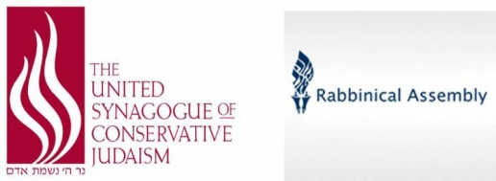

August 31, 2017 – 9 Elul 5777
The Honorable Benjamin Netanyahu
Prime Minister of the State of Israel
Jerusalem, Israel
Dear Mr. Prime Minister,
We the undersigned represent the rabbinic and lay leadership of Conservative Judaism including approximately 850 kehillot worldwide, 1700 rabbis, camps, schools, college campuses and national and international Jewish organizations; approximately two million Jews worldwide. We are writing to express to you our dismay, anger and sense of betrayal concerning the events of June 25, 2017 in which the Cabinet tabled the Kotel Agreement of January 2016 and simultaneously the Legislative Committee of the Knesset put forward a new Conversion Law that would codify the Rabbanut as the sole authority in Israel for conversion to Judaism.
Mr. Prime Minister, we are Zionists. We have, will and continue to support Israel as the realization of the Jewish dream “lihiyot Am chofshee b’artzeynu – to be a free people in our Land.” You must understand, however, that in the 21st century we find it unconscionable that Israel, the Jewish State, is the only democratic state in the world in which not all Jews are recognized or supported equally under the law or in the public square. For decades we have put aside our self-interest of recognition for the values of Klal Yisrael and for assuring the building of Israel’s infrastructure and security. We live in a different context today than did our grandparents at the time of Israel’s founding and our parents in the aftermath of the Six Day War. The status quo is no longer tenable or tolerable.
In our view the Kotel Agreement, the Conversion Law, and frankly all issues of personal status in the Jewish State are linked. The time has come for Israel to end the Rabbanut monopoly on the Judaism of the Jewish State. The time has come for Israel to embrace Jewish pluralism as a positive value to ensure the Jewishness of the Jewish State and its democratic values.

We call upon you, therefore, to immediately implement the Kotel Agreement that you yourself led in serious negotiations with our partners the Jewish Agency, the Jewish Federations of North America, the Reform Movement, Women of the Wall and us. We call upon you to assure that any Conversion Law put forward recognizes the diversity of Klal Yisrael in determining who is a Jew and does not allow for a Rabbanut monopoly in Israel or elsewhere in such determinations.
In a few short weeks Jews around the world will gather in sacred community to celebrate the Yamim Noraim. Our rabbis will preach words of introspection and inspiration toward living a meaningful Jewish life. We will speak about Israel as an ideal as portrayed in our liturgy and as reality. We will encourage our community to purchase Israel Bonds, to visit, to make Aliyah and to support our Masorti Movement institutions that further Jewish pluralism in Israel.
Mr. Prime Minister, you can influence the content of our Yamim Noraim messages. Will we speak of Israel’s reality in a language of betrayal or hope? Will we speak of struggle or achievement? We ask you to lead; we ask you to fulfill your promise to us that Israel will be the homeland of the entire Jewish people – Reform, Conservative, Orthodox and secular.

Bkhavod Rav,

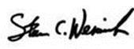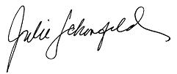
Rabbi Steven Wernick, CEO Rabbi Julie Schonfeld, CEO
USCJ The Rabbinical Assembly

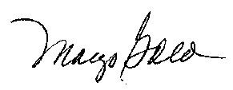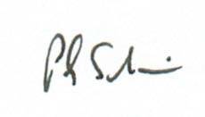
Margo Gold, President Rabbi Philip Scheim, President
USCJ The Rabbinical Assembly

